**DAILY ONLINE ACTIVITIES SUMMARY**

|  |  |  |  |  |  |  |  |  |
| --- | --- | --- | --- | --- | --- | --- | --- | --- |
| **Date:** | **19/05/2020** | | | | | **Name:** | **Felina Menezes** | |
| **Sem & Sec** | **4th SEM 'A' Section** | | | | | **USN:** | **4AL18CS021** | |
| **Online Test Summary** | | | | | | | | |
| **Subject** | | **Design and Analysis of Algorithms** | | | | | | |
| **Max. Marks** | | **30** | | **Score** | | | **19** | |
| **Certification Course Summary** | | | | | | | | |
| **Course** | **1.Python In Machine Learning**  **2.Python Workshop – by Brain O vision solutions** | | | | | | | |
| **Certificate Provider** | | | **1. Great Learning Academy**  **2. Brain O Vision pvt.Ltd** | | **Duration** | | | **1. 45 min**  **2. 90 min** |
| **Coding Challenges** | | | | | | | | |
| **Problem Statement: 1.**  Write a simple code to identify given linked list is palindrome or not by using stack.  2. Write down a Java program to print even and odd numbers series respectively. | | | | | | | | |
| **Status: completed** | | | | | | | | |
| **Uploaded the report in Github** | | | | | **Yes** | | | |
| **If yes Repository name** | | | | | https://github.com/felinamenezes/lockdown-coding.git | | | |
| **Uploaded the report in slack** | | | | | **Yes** | | | |

ONLINE TEST DETAILS: Online test was conducted on the first module of Design and Analysis of Algorithm. Test contains 20 questions of 1 Mark each and 5 questions of 2 Mark each.

Snapshot:



Certification Course Details: Today I have done with two certification course:

1. Python In Machine Learning, Here I have learnt about the Logical Operators, Strings, hands on data structures used in Python.
2. The workshop on Python for beginners.

Snapshot:

1.

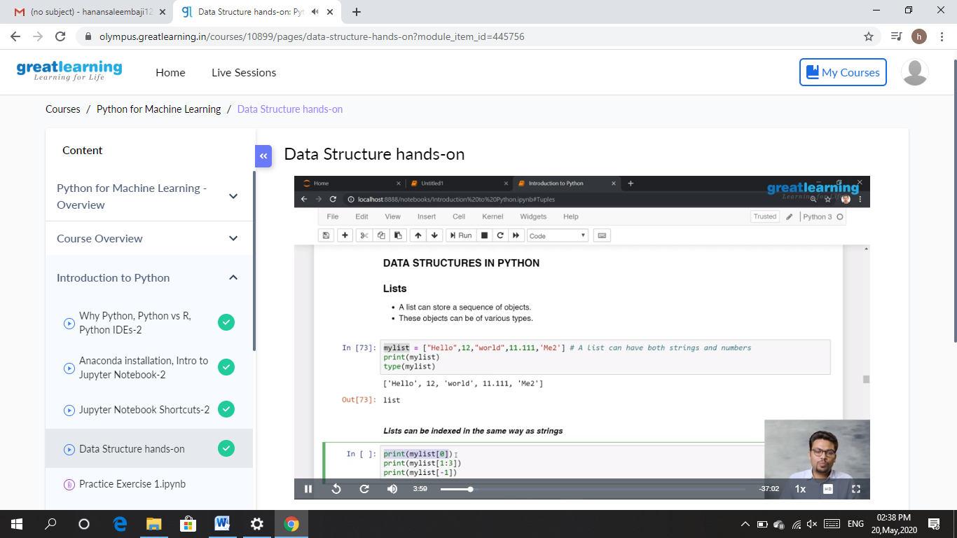

2.

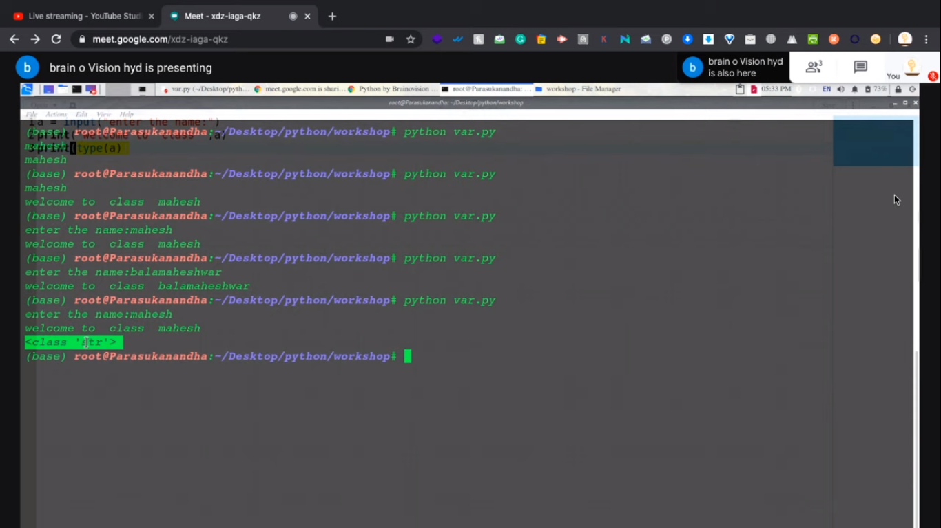

CODING CHALLENGES DETAILS: Problem statements

1. Write a simple code to identify given linked list is palindrome or not by using stack.

First take a stack. Traverse through each node of the linked list and push each node value of stack.

Once the traversal and copying is done, iterate through linked list from head node again.

In each iteration, pop one stack element and compare with node value in respective iteration. It is expected to match stack popped value with node value.

In case of all matches, its a palindrome. Any one element mismatch makes it not a palindrome.

Solution : Uploaded it in github

Snapshot:

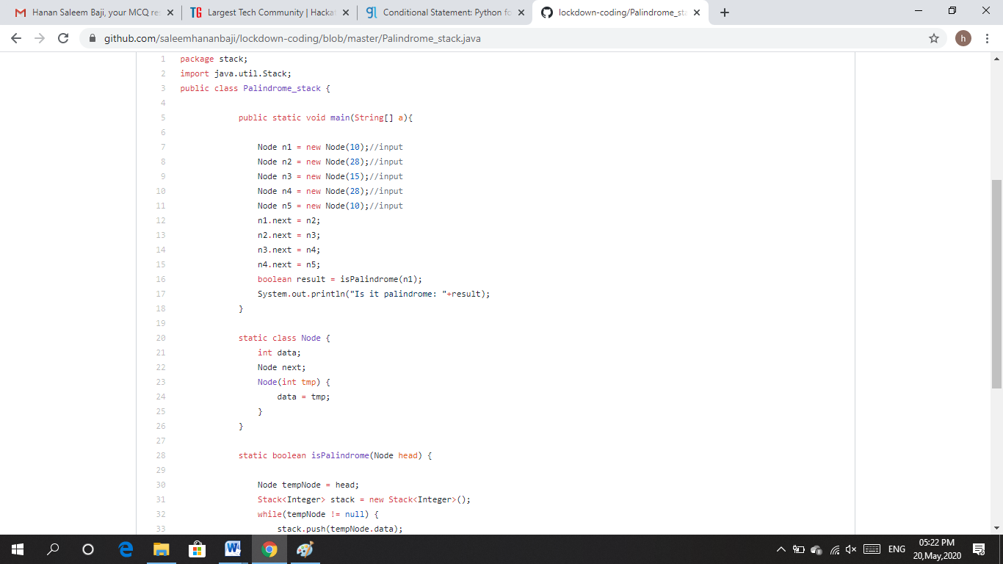

1. Write down a Java program to print even and odd numbers series respectively.

From two threads: t1 and t2 synchronizing on a shade object.

Let t1 print message “ping ->” and t2 print message “,--pong”.

Take as command line arguments, the following inputs to the program sleep interval for thread t1

Write down a Java program to print even and odd numbers series respectively from two threads: t1 and t2 synchronizing on a shade object.

Let t1 print message “ping ->” and t2 print message “,--pong”.

Take as command line arguments, the following inputs to the program

sleep interval for thread t1

sleep interval for thread t2

Message per cycle

No.of cycles

Solution : Uploaded it in github

Snapshot:

